Project Design Phase-II

Data Flow Diagram & User Stories

|  |  |
| --- | --- |
| Date | 17 November 2022 |
| Team ID | PNT2022TMID43833 |
| Project Name | Classification of Arrhythmia by Using Deep Learning with 2-D ECG Spectral Image Representation |
| Maximum Marks | 4 Marks |

**Data Flow Diagrams:**

A Data Flow Diagram (DFD) is a traditional visual representation of the information flows within a system. A neat and clear DFD can depict the right amount of the system requirement graphically. It shows how data enters and leaves the system, what changes the information, and where data is stored.

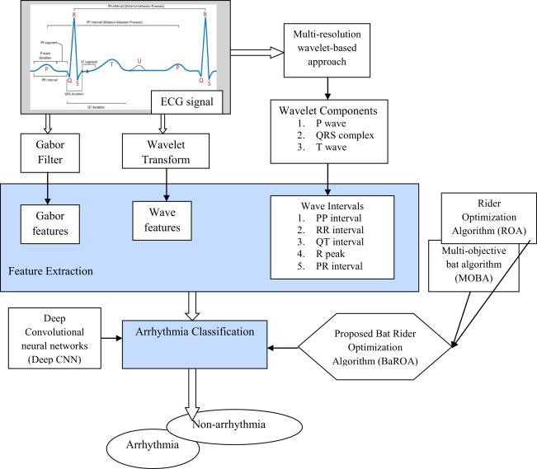

**User Stories**

Use the below template to list all the user stories for the product.

|  |  |  |  |  |  |  |
| --- | --- | --- | --- | --- | --- | --- |
| **User Type** | **Functional Requirement (Epic)** | **User Story Number** | **User Story / Task** | **Acceptance criteria** | **Priority** | **Release** |
| **Customer (Mobile user)** | Registration | USN-1 | As a user, I can register for the application by entering my email, password, and confirming my password. | I can access my account / dashboard | High | Sprint-1 |
|  |  | USN-2 | As a user, I will receive confirmation email once I have registered for the application | I can receive confirmation email & click confirm | High | Sprint-1 |
|  |  | USN-3 | As a user, I can register for the application through Facebook | I can register & access the dashboard with Facebook Login | Low | Sprint-2 |
|  |  | USN-4 | As a user, I can register for the application through Gmail | Access gmail and dashboard | Medium | Sprint-1 |
|  | Login | USN-5 | As a user, I can log into the application by entering email & password | Enter and access with password and email | High | Sprint-1 |
|  | Dashboard | USN-6 | As a web user grid format which | Seeing information | low | Sprint-2 |

|  |  |  |  |  |  |  |
| --- | --- | --- | --- | --- | --- | --- |
| **User Type** | **Functional Requirement (Epic)** | **User Story Number** | **User Story / Task** | **Acceptance criteria** | **Priority** | **Release** |
|  |  |  | makes it easy to see | through dashboard |  |  |
| **Customer (Web user)** | Registration | USN-1 | As a user, I can register for the application by entering my email, password, and confirming my password. | I can access my account / dashboard | High | Sprint-1 |
|  | Conformation | USN-2 | As a user, I will receive confirmation email once I have registered for the application | I can receive confirmation email & click confirm | High | Sprint-1 |
|  |  | USN-3 | As a user, I can register for the application through Facebook | I can register & access the dashboard with Facebook Login | Low | Sprint-2 |
|  |  | USN-4 | As a user, I can register for the application through Gmail | Register access with gmail | Medium | Sprint-1 |
|  | Login | USN-5 | As a user, I can log into the application by entering email & password | Access the dashboard with email and passwords | High | Sprint-1 |

|  |  |  |  |  |  |  |
| --- | --- | --- | --- | --- | --- | --- |
| **User Type** | **Functional Requirement (Epic)** | **User Story Number** | **User Story / Task** | **Acceptance criteria** | **Priority** | **Release** |
| **Customer care** | Login | USN-1 | I can easily laid out information | Seeing information with dashboard | Low | Sprint-1 |
|  | Dashboard | USN-2 | Team of representatives offering customer support | Offer support for customer | High | Sprint-2 |
|  | Responsibilities | USN-3 | Revolve customer compliants | Resolve customer complaints and bring to attention | High | Sprint-1 |
| **User Type** | **Functional Requirement (Epic)** | **User Story Number** | **User Story / Task** | **Acceptance criteria** | **Priority** | **Release** |
| **Administrator** |  |  |  |  |  |  |
| hospital staff | User Registration | USN-  1 | Registration to the respective hospital through the Hospitals website by entering your name,age, phone number and address | I can get the details of thelist of doctors available based on their specialty | high | sprint-  1 |
|  | Registration Options | USN-  2 | As a staff, I can register for the application through the hospital's | I can register & access the  Healthcare Panel | high | Sprint-2 |

|  |  |  |  |  |  |  |
| --- | --- | --- | --- | --- | --- | --- |
| **User Type** | **Functional Requirement (Epic)** | **User Story Number** | **User Story / Task** | **Acceptance criteria** | **Priority** | **Release** |
|  | available |  | official website | which  prompts reminders about your heart rhythms |  |  |
|  | Login | USN-3 | As a Healthcare staff, I can log in to the application by entering the right credentials like phone number and password |  | low | Sprint-  1 |
|  | Dashboard | USN-4 | Enables healthcare professionals to access important patient statistics in real-time |  | high | Sprint-1 |